PIZZA SALES ANALYSIS
SQL QUERIES & KPI DOCUMENTATION
DATASET: PIZZA_SALES | TOOL: MS SQL SERVER | VISUALISATION: POWER BI

SECTION 1 - KPI METRICS
TOTAL REVENUE
SELECT SUM( total_price) AS Total_Revenue from pizza_sales;
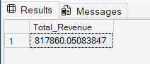

AVERAGE ORDER VALUE
SELECT SUM (total_price)/COUNT(DISTINCT order_id) AS total_orders from pizza_sales ;



AVERAGE PIZZAS PER ORDER
SELECT CAST(CAST(SUM(quantity) AS DECIMAL(10,2)) /
CAST(COUNT(DISTINCT order_id) AS DECIMAL(10,2)) AS DECIMAL (10,2)) AS avg_pizzas_per_order
FROM pizza_sales;

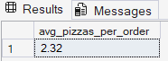

TOTAL ORDERS
SELECT COUNT(DISTINCT order_id) AS total_orders
FROM pizza_sales;

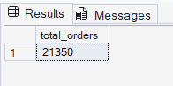

TOTAL PIZZA SOLD
SELECT SUM(quantity) AS total_pizzas_sold
FROM pizza_sales;
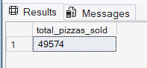

SECTION 2 — SALE ANALYSIS
DAILY TREND OF TOTAL ORDERS
SELECT DATENAME(WEEKDAY, order_date) AS day,
COUNT(DISTINCT order_id) AS total_orders
FROM pizza_sales
GROUP BY DATENAME(WEEKDAY, order_date);

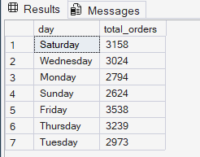

MONTHLY TREND OF TOTAL ORDERS
SELECT DATENAME(MONTH, order_date) AS month,
COUNT(DISTINCT order_id) AS total_orders
FROM pizza_sales
GROUP BY DATENAME(MONTH, order_date);

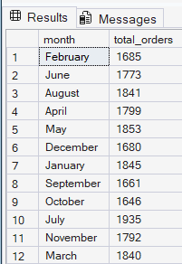

SECTION 3 — SALES BREAKDOWN
PERCENTAGE OF TOTAL SALES BY PIZZA CATEGORY
SELECT pizza_category,
CAST(SUM(total_price) * 100.0 / (SELECT SUM(total_price)
FROM pizza_sales)AS DECIMAL(10,2)) AS percentage FROM pizza_sales
GROUP BY pizza_category;



TOTAL PIZZAS SOLD BY PIZZA CATEGORY
SELECT pizza_category,
SUM(quantity) AS total_quantity_sold
FROM pizza_sales
GROUP BY pizza_category
ORDER BY total_quantity_sold DESC;

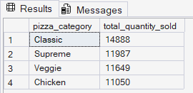

PERCENTAGE OF TOTAL SALES BY PIZZA CATEGORY FOR JANUARY ONLY
SELECT pizza_category,
CAST(
SUM(total_price) * 100.0 /
(SELECT SUM(total_price)
FROM pizza_sales
WHERE MONTH(order_date) = 1)
AS DECIMAL(10,2)) AS percentage
FROM pizza_sales
WHERE MONTH(order_date) = 1
GROUP BY pizza_category;

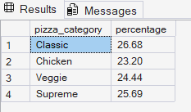

TOTAL SALES AND PERCENTAGE OF SALES BY PIZZA SIZE
SELECT pizza_size,
SUM(total_price) AS total_sales,
CAST(
SUM(total_price) * 100.0 /
(SELECT SUM(total_price) FROM pizza_sales)
AS DECIMAL(10,2)) AS pct
FROM pizza_sales
GROUP BY pizza_size
ORDER BY pct DESC;
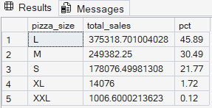

TOTAL SALES AND PERCENTAGE OF SALES BY PIZZA SIZE FOR Q1 ONLY
SELECT pizza_size,
CAST(SUM(total_price) AS DECIMAL(10,2)) AS total_sales,
CAST(
SUM(total_price) * 100.0 /
(SELECT SUM(total_price)
FROM pizza_sales
WHERE DATEPART(QUARTER, order_date) = 1)
AS DECIMAL(10,2)) AS pct
FROM pizza_sales
WHERE DATEPART(QUARTER, order_date) = 1
GROUP BY pizza_size
ORDER BY pct DESC;

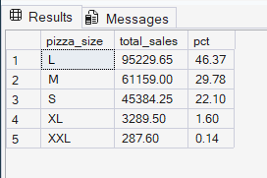

TOP 5 PIZZAS BY REVENUE
SELECT TOP 5 pizza_name, sum(total_price) AS Total_Revenue FROM pizza_sales
GROUP BY pizza_name
ORDER BY Total_Revenue DESC;

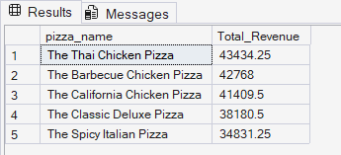

TOP 5 BEST-SELLING PIZZAS BY QUANTITY SOLD
SELECT TOP 5 pizza_name, sum(quantity) AS Total_Quantity FROM pizza_sales
GROUP BY pizza_name
ORDER BY Total_Quantity DESC;

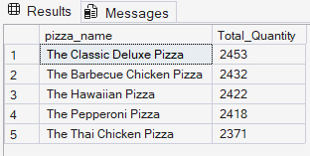

BOTTOM 5 PIZZAS BY QUANTITY SOLD
SELECT TOP 5 pizza_name,
SUM(quantity) AS total_quantity
FROM pizza_sales
GROUP BY pizza_name
ORDER BY total_quantity ASC;

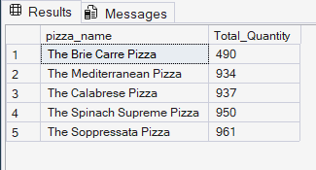

BOTTOM 5 PIZZAS BY TOTAL ORDERS
SELECT TOP 5 pizza_name,
COUNT(DISTINCT order_id) AS total_orders
FROM pizza_sales
GROUP BY pizza_name
ORDER BY total_orders ASC;

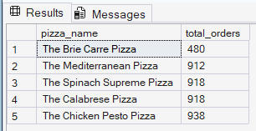

TOP 5 PIZZAS BY TOTAL ORDERS
SELECT TOP 5 pizza_name,
COUNT(DISTINCT order_id) AS total_orders
FROM pizza_sales
GROUP BY pizza_name
ORDER BY total_orders DESC;

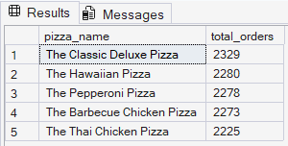

BOTTOM 5 PIZZAS BY REVENUE
SELECT TOP 5 pizza_name,
SUM(total_price) AS total_revenue
FROM pizza_sales
GROUP BY pizza_name
ORDER BY total_revenue ASC;

